***1. Check if a String is a Palindrome***

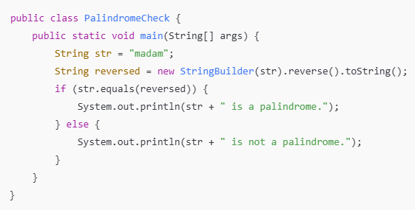

***2. Check if a Number is Positive or Negative***

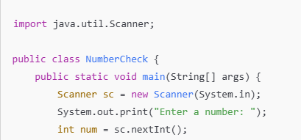

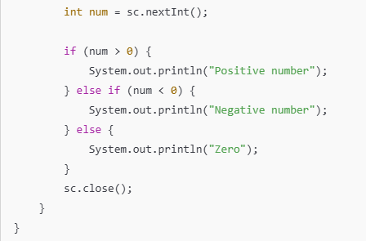

***3. Remove Duplicate Elements from an ArrayList***

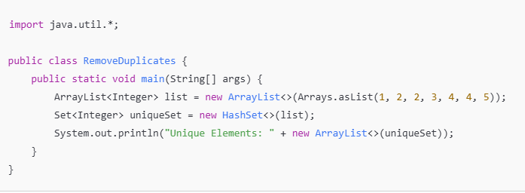

***4. Remove Junk Characters from a String***

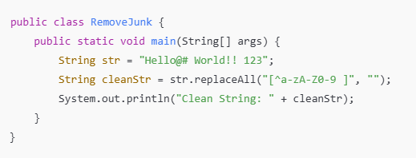

***5. Remove All White Spaces from a String***

